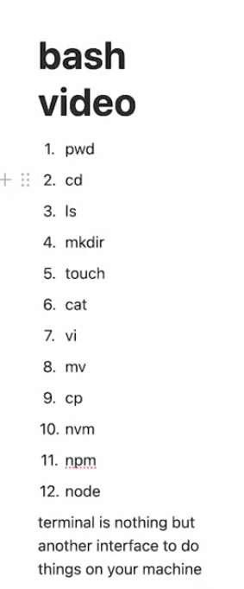

const express=require("express");

const app=express();

const port=3000;

app.use(express.json());

function calculateSumOfn(n){

    let sum=0;

    for(let i=1;i<=n;i++){

        sum+=i;

    }

    return sum;

}

app.get("/",(req,res)=>{

    // res.send("Hello World");

    let n=req.query.n;

    calculateSumOfn(n);

    res.send(calculateSumOfn(n).toString());

});

app.listen(port,()=>{

    console.log(`Server is running on http://localhost:${port}`);

} );

<http://localhost:3000/?n=30>

==================================================================================

map

function even(num) {

  for(let i = 0; i < num.length; i++) {

      num[i]=num[i]\*2

  }

  return num;

}

console.log(even([1, 2, 3, 4, 5, 6, 7, 8, 9, 10]));

function transform(i)

{

  return i \* 2;

}

const arr = [1, 2, 3, 4, 5, 6, 7, 8, 9, 10];

const ans=arr.map(transform);

console.log(ans);

const input = [1, 2, 3, 4, 5, 6, 7, 8, 9, 10];

const ans=input.map(function(i){

    return i \* 2;

  });

  console.log(ans);

  const input = [1, 2, 3, 4, 5, 6, 7, 8, 9, 10];

const ans=input.map((i) => {

  return i \* 2;

} );

console.log(ans);

// map, filter , arrow fns

const arr=[1, 2, 3, 4, 5, 6, 7, 8, 9, 10];

const ans=arr.filter((num) => {

    return num%2===0;

}

).map((num) => {

    return num\*num;

}

).reduce((acc, num) => {

    return acc+num;

}

, 0);

console.log(ans); // 440

filter

// map, filter , arrow fns

const arr=[1, 2, 3, 4, 5, 6, 7, 8, 9, 10];

const ans=arr.filter((num) => {

    return num%2===0;

})

console.log(ans); // [2, 4, 6, 8, 10]

reduce